**Development of Virtual lab :Round 2 (R2)-Storyboard - Template (Worksheet)**

|  |
| --- |
| **Name of Faculty:** **Dr. Amit Tripathi**  **Institute: Rajkiya Engineering College Banda**  **Email ID** (as submitted in the registration form)**: amittri13@gmail.com**  **Discipline to which the Lab belongs: Computer Science & Engineering**  **Name of the Lab: Data Structures Lab**  **Name of experiment: Operations on Queue ADT using Linked List**  **Kindly Refer these documents before filling the worksheet**   1. **Coursework (MOOC ) on Pedagogy , Storyboard , Lab Manual :**  [**http://bit.ly/Vlabs-MOOC**](http://bit.ly/Vlabs-MOOC) 2. **Additional Documentation booklet for reference.** [**http://vlabs.iitb.ac.in/vlabs-dev/document.php**](http://vlabs.iitb.ac.in/vlabs-dev/document.php) 3. **Sample Git Repository. :** |

**Round 2**

**1. Story Outline:**

Queue is a data structure in which the elements are added at one end, called the rear, and deleted from the other end, called the front. It is a First In First Out data structure (FIFO). The rear of the queue is accessed whenever a new element is added to the queue, and the front of the queue is accessed whenever an element is deleted from the queue. There are two basic operations which can be implemented on the linked queues. The operations are Insertion and Deletion.

There can be the two scenario of insertion into the linked queue.In the first scenario, we insert element into an empty queue. In the second case, the queue contains more than one element. With each insertion the position of REAR is incremented by 1. In linked list implementation of a queue a new element is always added at the tail of the list and d-eleted from the head of the linked list.  The essential condition which is checked before insertion in a linked queue is overflow. Deletion operation removes the element that is first inserted among all the queue elements. There are again two cases that whether the list is empty or the list contains some elements. With each deletion the position of FRONT is incremented by 1. The essential condition which is checked before insertion in a linked queue is overflow

**2. Story:**

**2.1 Set the Visual Stage Description:**

1)Enter elements in the queue

2) Press the ‘Enter’ button

3) Click the ‘Insertion’ button

4) Click the ‘Deletion’ button

**2.2 Set User Objectives & Goals:**

1) Recall the concept of queue

2) Understand the mechanism of ‘Insertion ‘

3) Understand the mechanism of ‘Deletion’

**2.3 Set the Pathway Activities:**

Student will perform the following steps :

1. Choose and enter the elements of the queue
2. Perform ‘Insertion’ operation
3. Perform ‘Deletion’ operation

**2.4 Set Challenges and Questions/Complexity/Variations in Questions:**

1. Student will be asked questions based on various cognitive levels. List of Questions is provided in Round1 document.

2. Student will be asked to solve questions based on the operations performed in the experiment

**2.5 Conclusion:**

Student will be able to understand the mechanism of ‘Insertion’ and ‘Deletion’ operations in linked queue.

**3. Flowchart**

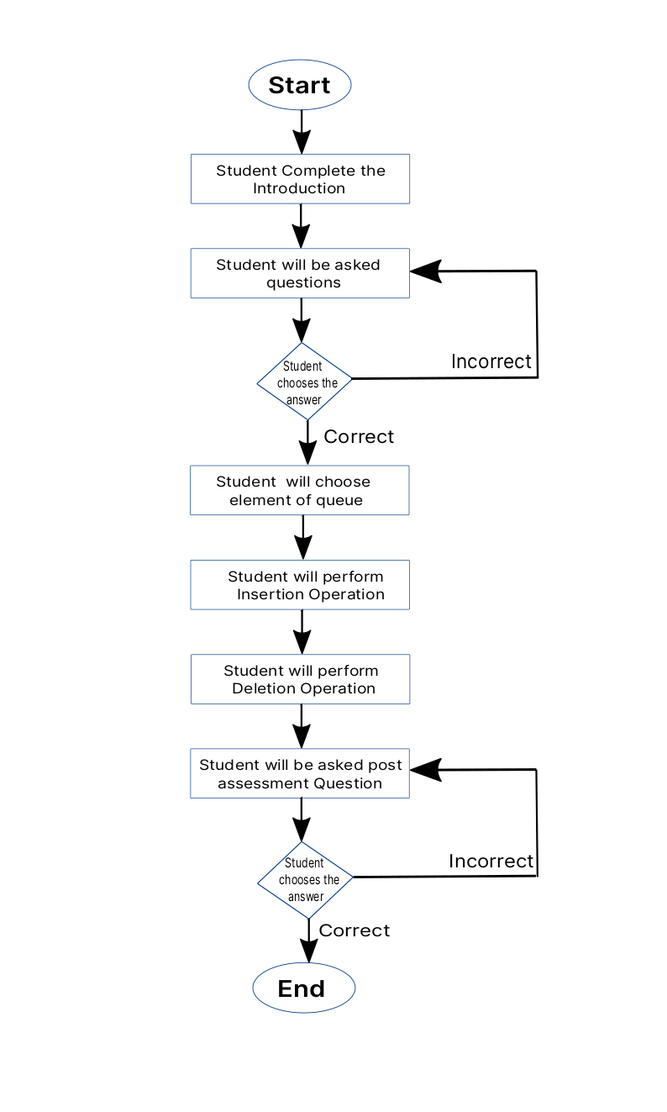

Figure: Flowchart of the V lab experiment for operations on Queue ADT using linked list

**4. Storyboard**

